Comparing Programming Languages Using a Data Processing Application

Introduction
For this exercise, it was decided that C and Python would be the languages to be tested against each other. This decision had been made based on personal knowledge of both languages and awareness of their vast differences, which could be clearly demonstrated even in a small application.

Development model
Python is most often described as a high-level language (de Sousa Miranda, 1999, pp. 2-3), meaning it abstracts low-level details such as memory addressing, allocation and clean up, or even data structures (Python 3.13.7 documentation). Unlike C, where it is necessary to free any allocated memory after use (Figure 1) or work with primitive data types such as char and int instead of using native dictionaries or tuples (Ritchie et al., 1977, p. 85). Another difference between the two is that Python is an object-oriented language, even though in C, object-like behaviour can also be achieved by using structs (Figure 2). On the other hand, Python can also be written fully procedurally - meaning it is possible to use no classes or methods at all, simply using functions (White and Sivitanides, 2005), thus making it equivalent to C. Python can also be considered a functional programming language, meaning it implements some of the core features of the paradigm, such as lambdas or lazy evaluation but it does not compare to purely functional languages like Haskell (Hu, Hughes and Wang, 2015). Both languages are therefore considered imperative.
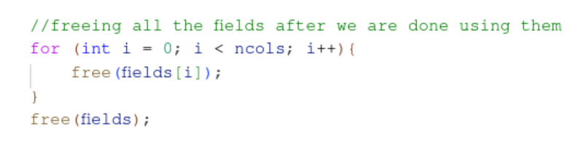
Figure 1
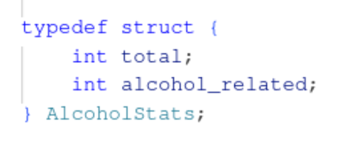
Figure 2

Performance
The area in which differences become most noticeable is performance. For the data processing utility, this dramatic difference is not what one might expect, though. It is generally known that C is faster than Python, especially because Python’s interpreter is written in C (Jun and Ling, 2010). This may not always be the case, especially when it comes to manually parsing large data files while also removing duplicate IDs. The latter, seemingly simple action, brings with it around 2.5 billion calls of a string comparison function on 74 thousand rows of data, which prolongs the time the code runs by around 3 seconds (Figure 3 using Python versus Figure 4 using C). Attempts to improve the time spent in execution using a hash table provided only minimal improvement (around 1 second). Overall, it can be said that even if the language is faster, doing unoptimized actions will result in slower execution, more resource-heavy, as was demonstrated in this case by comparing the Pandas library (pandas documentation, 2025) in Python, which is highly optimised for working with data versus plain C.
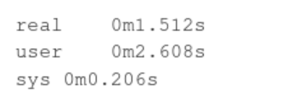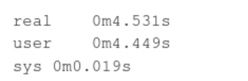
Figure 3 Figure 4

Security
Security is a difficult topic when discussing any programming language and is usually a deciding factor in choosing said language for enterprise or personal use instead of its competitors. While it can be said that any language will inevitably encounter vulnerabilities, C tends to come up on both sides of the spectrum (Salka, 2005). Its strict, typed syntax and few functions in the standard libraries leave very little room for errors. On the other hand, and for the same reasons, it introduces many potential issues via its simplistic approach. Buffer overflow, interchanging pointers and values or dealing with signed and unsigned integers - to name a few (Seacord, 2013). When it comes to the data processing script written in C, the biggest issue was dynamic memory management, mainly memory leaks. This is one of the pillars of the language; when you allocate any memory, you also need to free it. C does not provide any checks directly, but using Valgrind (valgrind, 2025), it is very simple to check if all memory has been freed. None of these issues come up in Python, as it is a highly abstracted language, not allowing us to work with memory or pointers directly. Python is not free of vulnerabilities either, and while they are not as integral a part of the language as in C, with ample packages and libraries used within Python, vulnerabilities are very common (Alfadel, Costa and Shihab, 2023).

Ease of development (syntax and readability, scalability and maintainability)
One of the biggest differences between the two languages is how easy they are to write, read, and maintain. Python’s syntax is designed to be human-readable and often described as close to pseudocode, which reduces the likelihood of errors. Indentation replaces curly braces and semicolons, and variable types are inferred automatically, allowing us to focus on logic rather than implementation details. On the other hand, C requires careful declaration of all variables and explicit memory handling. This means more control but also more verbosity and potential mistakes. This fact has been showcased on these two scripts as well - while it took around 5 hours and 150 lines of code to write the Python code, it took about three times as much time and code to write the same app in C.
When it comes to scalability and maintainability, Python makes use of its sizable standard library and a variety of packages ,which make it possible to expand functionality with minimal effort. Libraries such as Pandas allow complex tasks to be written in just a few lines, whereas in C they might require hundreds. However, C still provides unmatched control and transparency, which can be beneficial for long-term maintainability (Roehm et al., 2019). The trade-off is that maintaining large C codebases often requires stricter coding standards and highly skilled developers.

Real-world applicability
Both Python and C have their place in the real world, but they are used for very different purposes. C remains a leader in systems programming, embedded devices, operating systems, and performance-critical applications such as databases. Its popularity and high demand are evident in comparison to other languages (Bissyandé et al, 2013, table II). Python, on the other hand, is heavily used in fields such as data science, automation and artificial intelligence. Its large ecosystem and simplicity mean that it is often the first choice for projects where speed of development and flexibility outweigh the need for raw performance (Artemov, 2023, p 11).
In the case of this exercise, Python proved to be the more efficient tool for data analysis despite its reputation for being slower, because libraries like Pandas are already optimised in C behind the scenes. C required far more manual effort to achieve similar results, and even then, optimisations made only a minimal difference compared to Python’s capabilities. This highlights the importance of choosing the right tool for the task. While C is powerful and close to the hardware, Python’s abstraction and libraries often make it more suitable for data processing tasks.

References:
- Alfadel, M., Costa, D.E. and Shihab, E. (2023) 'Empirical analysis of security vulnerabilities in Python packages', Empir Software Eng, 28(59). Available at: https://doi.org/10.1007/s10664-022-10278-4
- Artemov, A. (2023) 'PROGRAMMING LANGUAGES IN DATA ENGINEERING: OVERVIEW, TRENDS AND PRACTICAL APPLICATION', pp. 9-13, Available at: https://www.researchgate.net/publication/394123197_PROGRAMMING_LANGUAGES_IN_DATA_ENGINEERING_OVERVIEW_TRENDS_AND_PRACTICAL_APPLICATION (Accessed: 4 October 2025).
- Bissyandé, T. F. et al. (2013) 'Popularity, Interoperability, and Impact of Programming Languages in 100,000 Open Source Projects', 2013 IEEE 37th Annual Computer Software and Applications Conference, pp. 303-312. Available at: https://doi.org/10.1109/COMPSAC.2013.55.
- de Sousa Miranda, D. (1999) “Python: a programming language for software integration and development,” J Mol Graph Model. Available at: https://d1wqtxts1xzle7.cloudfront.net/25505223/10.1.1.35.6459-libre.pdf?1390869360=&response-content-disposition=inline%3B+filename%3DPython_a_programming_language_for_softwa.pdf (Accessed: 4 October 2025).
- Hu, Z., Hughes, J. and Wang, M. (2015) ' How functional programming mattered', National Science Review, 2(3), pp. 349 – 370. Available at: https://doi.org/10.1093/nsr/nwv042
- Jun, L. and Ling, L. (2010) 'Comparative research on Python speed optimization strategies', International Conference on Intelligent Computing and Integrated Systems, pp. 57 - 59. Available at: https://doi.org/10.1109/ICISS.2010.5655011
- pandas documentation (2025) Available at: https://pandas.pydata.org/docs/ (Accessed: 4 October 2025).
- Python 3.13.7 documentation (no date) Available at: https://docs.python.org/3/ (Accessed: 4 October 2025).
- Ritchie, D. M. et al. (1978) 'The C Programming Language', THE BELL SYSTEM TECHNICAL JOURNAL, 57(6). Available at: https://www.academia.edu/49502823/1978_JULY_THE_BELL_SYSTEM_TECHNICAL_JOURNAL_UNIX_#title (Accessed: 4 October 2025).
- Roehm, T. et al. (2019) 'Evaluating Maintainability Prejudices with a Large-Scale Study of Open-Source Projects', Software Quality: The Complexity and Challenges of Software Engineering and Software Quality in the Cloud, 338. Available at: https://doi.org/10.1007/978-3-030-05767-1_10
- Salka, C. (2005) 'Programming languages and systems security', IEEE Security & Privacy, 3(3), pp. 80 - 83. Available at: https://doi.org/10.1109/MSP.2005.77
- Seacord, R. C. (2013) Secure Coding in C and C++. Available at: https://raw.githubusercontent.com/DarkCodeOrg/welcome-to-cybersecurity/master/secure%20coding%20in%20c%20and%20c%2B%2B.pdf (Accessed: 4 October 2025).
- valgrind (2025) Available at: https://valgrind.org/ (Accessed: 4 October 2025).
- White, G. and Sivitanides, M. (2005) 'Cognitive Differences Between Procedural Programming and Object Oriented Programming', Inf Technol Manage, 6, pp. 333 - 350. Available at: https://doi.org/10.1007/s10799-005-3899-2

